JOY OF ENGINEERING

**SAFE ZONE**

Project Report

SUBMITTED IN PARTIAL FULFILLMENT REQUIREMENT FOR THE AWARD OF DEGREE OF

**BACHELOR OF TECHNOLOGY**

SUBMITTED BY GROUP - 10

|  |  |
| --- | --- |
| **Name** | **Roll number** |

SRI CHARAN 240660

KEERTHANA 240509

KARTHIKEYA 240730

SRI SURYA 240495

UNDER THE SUPERVISION OF

**Dr. Devanjali Relan**

**Dr. Pooja Choudhary**

SCHOOL OF ENGINEERING AND TECHNOLOGY

**BML MUNJAL UNIVERSITY Gurugram, Haryana - 122413**

**May 2025**

**CANDIDATE’S DECLARATION**

We Sri Charan, Keerthana, Sri Surya, Karthikeya, hereby declare that the project entitled *"Safe Zone*" in fulfilment of completion of the 2nd-semester course – Joy of Engineering as part of the Bachelor of Technology (B.TECH) program at the School of Engineering and Technology, BML Munjal University is an authentic record of our work carried out under the supervision of Dr. Devanjali Relan and Dr.Pooja Choudhary. Due acknowledgments have been made in the text of the project to all other materials used.

This project was done in full compliance with the requirements and constraints of the prescribed curriculum.

Sri Charan            240660

Keerthana           240509

Sri Surya           240730

Karthikeya           240495

Place: BML Munjal University

Date: 15-05-2025

**SUPERVISOR’S DECLARATION**

This is to certify that the above statement made by the candidate is correct to the best of my knowledge.

Faculty Supervisor Name: Dr. Devanjali Relan and Dr.Pooja Choudhary

Signature:

**ABSRACT**

The Safe Zone project provides an intelligent tracking wearable system optimized to target the distinctive safety issues of individuals suffering from Alzheimer’s illness. Developed as a smart lock-supported smartwatch, the system involves a mixture of GPS tracking, geo-fencing, and an SOS alert system to monitor the patient in real time. Employing parts like the Arduino Uno board, GPS and GSM modules, and an encrypted smart lock system, the project functions as much as patient safeguarding. In contrast to commercially available products which are too costly or non-wearable safe, Safe Zone provides a low-price and tamper-evident option. The system design features both cloud and local data management to inform caregivers under any network condition. Not only does the project enhance the independence and safety of Alzheimer's patients but also reduce the burden on caregivers by providing real-time real data and alarms. Future extensions may involve incorporating biometric sensing, AI-enabled behavioural monitoring and alerts and inclusion in a smartphone app to render Safe Zone a scalable and efficient assistive healthcare tool.

**ACKNOWLEDGEMENT**

We extend our deepest gratitude to everyone who contributed to the successful development of the Safe Zone project, we recognize the invaluable contributions of numerous individuals and entities who have supported us throughout this endeavour.

We extend our heartfelt appreciation to Dr. Devanjali Relan and Dr. Pooja Choudhary for their invaluable guidance and unwavering support. Her expertise and mentorship have been pivotal in shaping our understanding of the subject matter.

Our sincere thanks are also due to the faculty and staff of the School of Engineering and Technology at BML Munjal University for providing us with the necessary resources and facilities to conduct our research effectively.

Furthermore, we acknowledge the contributions of our peers and classmates for their constructive feedback and assistance, which have been invaluable in the development of this report.

To everyone who has played a part, whether through advice, support, or emotional encouragement, we extend our sincerest thanks. Your contributions, no matter how small, have been instrumental in the completion of this report.

Sri Charan 240660

Sri Surya 240495

Keerthana 240509

Karthikeya 240730

**LIST OF FIGURES**

| **Figure No** | **Figure Description** | **Page Number** |
| --- | --- | --- |
| 1 | Project On Breadboard | 1 |
| 2 | Circuit Design Using Arduino Uno and GPS Module | 5 |
| 3 | Key Components | 5 |
| 4 | Workflow Of the Prototype | 6 |
| 6 | Component Casing | 7 |
| 7 | Landing Page and Sign in Interface of the Website | 10 |
| 8 | Dashboard and Live location Interface of the Website | 11 |
| 9 | Geofencing and SOS Interface of the Website | 12 |
|  |  |  |
|  |  |  |

**TABLE OF CONTENTS**

**Candidate and Supervisor’s Declaration........................................... i**

**Acknowledgment....................................................................... ii**

**List of Figures.......................................................................... iii**

**Abstract ................................................................................. iv**

**1. Chapter-1 – Introduction...................................................................1**

**2. Chapter-2 – Literature Review..........................................................2**

**2.1 Introduction**

**2.1.1 Current technologies and tools**

**2.1.2 Technological innovations in assistive devices**

**2.1.3 User-centred design in medical devices**

**2.2 Research gap**

**2.3 Objectives of project**

**3. Chapter-3 – Experimental Setup.....................................................4**

**3.1 Conceptual sketch**

**3.2 Materials used**

**4. Chapter-4 – Results and Observations.......................................... 6**

**5. Chapter-5 – Conclusion and Future Scope .................................. 7**

**6. Our Website ……………………………………………………… 8**

**References.............................................................................................8**

1 | P a g e

**CHAPTER 1**

**INTRODUCTION**

Alzheimer’s disease is a progressive neurodegenerative condition marked by the degradation of cognitive functions including memory, reasoning, and spatial awareness. One of the most troubling symptoms is the susceptibility of patients to wandering, with little sense of direction and minimal awareness of risk. This not only subjects the patient to a high risk of harm but also causes caregivers much anxiety and difficulty in monitoring and response. The requirement of simple, effective, and safe tracking solutions to support such individuals is the essential to ensure their protection and to bring peace to caregivers.

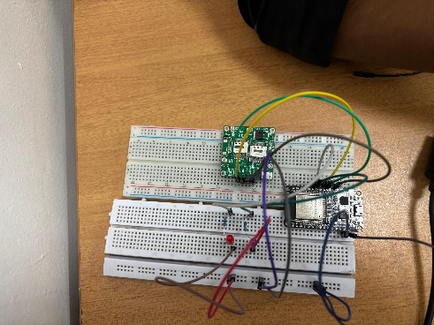  
**BEGGINING OF THE PROJECT ON BREAD BOARD**

The idea behind the Safe Zone project was born out of this urgent need for safety and tracking solutions for individuals afflicted by Alzheimer’s and other forms of dementia. A fundamental objective is to create a wearable and lockable GPS tracking system—in the form of a smartwatch—providing real-time location tracking, geo-fencing, and a built-in SOS alert system. With tamper-resistant locking and mobile connectivity, the system enables round-the-clock surveillance without infringing on the comfort and dignity of the user.

A core emphasis of the Safe Zone device is its affordability, accessibility, and simplicity. Unlike many commercial options that are either too expensive or lack adequate security, the device uses low-cost hardware like the Arduino Uno and GPS/GSM modules within a custom-built housing. It is designed to resist unauthorized removal and deactivation. This report outlines the motivation, design, and technical aspects of the Safe Zone project.

2 | P a g e

**CHAPTER 2**

**2.LITERATURE REVIEW**

**2.1 Introduction**

Alzheimer's disease poses an escalating global healthcare threat with caregivers tending to constantly monitor the patient to counter forgetfulness, confusion, and wandering. Consequently, the past has witnessed a proliferation of assistive devices to guarantee patient protection and minimize caregiver strain. This review discusses existing tech solutions in monitoring and protecting Alzheimer's sufferers, notes shortcomings in the current approaches, and proposes user-centric, low-price, and tamper-proof devices as essential.

**2.1.1 Current Technologies and Tools**

Some products commercially available are intended to help caregivers track Alzheimer’s patients. These products such as SecuLife GPS Tracker and Benbengo Smart Locator employ GSM and GPS modules to track individuals in real-time. The products usually come with features such as geofencing, fall alerts, and alert notices. They do not usually involve any physical security features to stop the removal of the device and are usually out of budget range for middle- or low-income households.

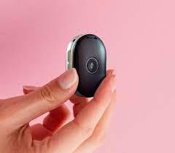

3 | P a g e

A study by Wang et al. (2019) on smart elderly care systems indicates that GPS-enabled devices markedly enhance patient safety but are hampered by low user compliance and battery life.

Likewise, Kaur and Saini (2021) highlight the necessity of mobile applications for responsiveness by caregivers but report that a majority of systems are subject to subscription services and bring additional costs to families.

**2.1.2 Technological Innovations in Wearable Devices**

The developments in wearable technology have opened the door to enhanced real-time monitoring of vulnerable populations. Arduino-compatible platforms and hardware such as the SIM800L GSM and Neo-6M GPS modules are commonly utilized in prototyping labs because they are available and compatible.

The research of Sharma et al. (2020) established the suitability of Arduino Uno and mobile network modules to monitor elderly patients in open environments. Their design was however capable of tracking user location but lacked a locking configuration and was tamperable or removable by the patient. This shows the requirement of having a hybrid system combining good hardware and robust physical protection mechanisms.

**2.1.3 User-Centred Design and Locking Mechanisms**

User-centric design is vital when designing healthcare tech. According to research by Liao and Huang (2018), patient adherence is boosted when wearables are safe, unobtrusive and light. Not many have embraced a protection against others removing the devices despite the advancements. The lack of safe attachment mechanisms means even advanced tracking systems might fail in practice. Biometric identification and mechanical locking emergent research have more informed directions but is used very little in commercially available solutions marketed towards care of Alzheimer’s. This highlights a gap in the necessity of devices having both material protection and digital exactness.

4 | P a g e

**2.1** **Research gap**

Although a variety of technical solutions have been developed to monitor and aid individuals suffering from Alzheimer’s disease, many fall short of expectations. Most devices on the market today can provide GPS tracking and panic alerts but are weak in terms of strong locking mechanisms. The result is that the devices are simple to remove or misplace by the patient and are subsequently useless when implemented in real life. Many products on today’s market are also out of budget and require subscription fees on a monthly basis, which makes it hard to afford for low-income households.

Another glaring shortcoming lies in offline data storage and synchronization. The majority of devices are solely dependent on the availability of the internet to transfer data, which in itself may or may not always become a reality in rural or far-flung areas. The ergonomics of available tracking solutions are also neglected at times to the extent of causing discomfort or rejection on the part of the user. The design elements following user-centric principles are also assigned less relevance while designing wearable tech to be delivered to elderly patients with weight, form factor, or usability constraints.

Therefore, a huge gap still exists in the development of a low-cost, tamper-resistant, user-friendly, and automated tracking system directly addressing the unique needs of Alzheimer’s victims and caregivers.

* 1. **Objectives of the Project:**
* To plan a wearable GPS tracking system to track Alzheimer’s patients in real time in a reliable and precise manner.
* For obtaining a tamper-resistant and safe locking system against removal of the device by a patient without a caregiver's consent.
* To provide caregivers with a natural mobile app to monitor individuals in real-time, receive geo-fencing notifications and send out SOS alerts in the event of any distress.

5| P a g e

**CHAPTER 3**

**EXPERIMENTAL SETUP**

**3.1 CIRCUIT DIAGRAM:**

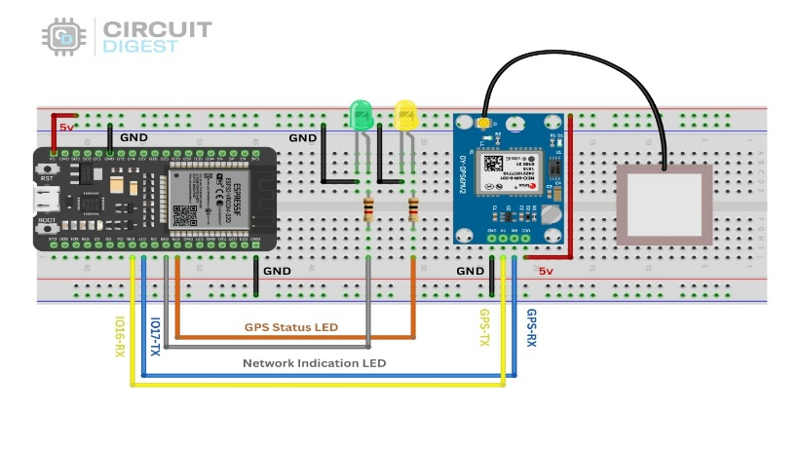

The experimental setup integrates these components to create a reliable, cost-effective solution for Alzheimer's patients, focusing on patient safety and caregiver peace of mind. Additionally, the system is designed to be affordable using readily available materials like the Arduino Uno and GSM modules, ensuring scalability for both households and healthcare institutions.

**Key Components:**

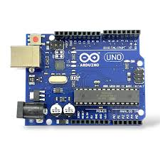 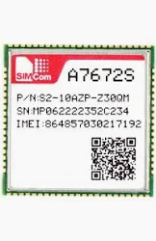 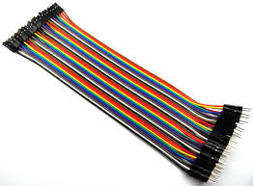 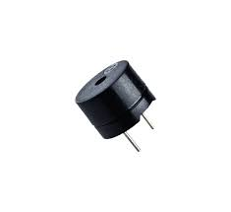  **ARDUINO UNO GPS MODULE JUMPER WIRES BUZZER**

6 | P a g e

**Workflow:**

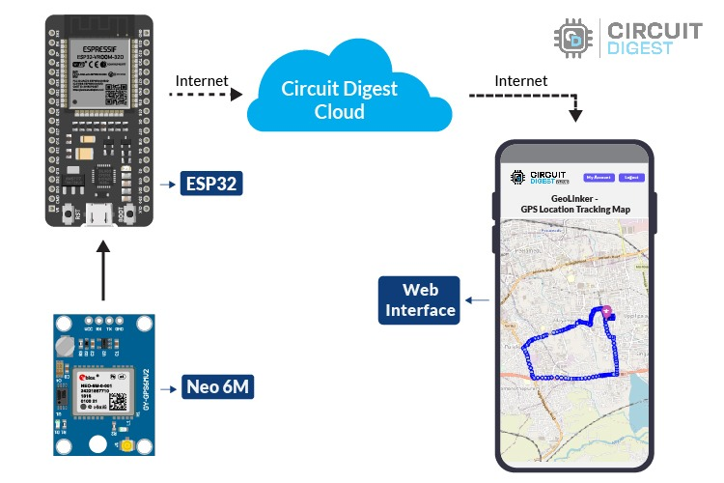

1. **Data Collection from Smartwatch**

* The smartwatch continuously captures **longitude and latitude coordinates** using the **A7672S GPS module**.

1. **Data Transmission to Cloud**

* The captured GPS coordinates are sent via **GSM/GPRS** to the **cloud server** at regular intervals.

1. **Cloud Storage**

* The longitude and latitude data is stored securely on the cloud database for real-time access and historical tracking.

1. **Backend Integration**

* The backend system retrieves the GPS data from the cloud, processes it if needed, and prepares it for frontend usage.

1. **Frontend Visualization**

* The website frontend fetches the GPS data via APIs and plots the real-time location of the patient on a map interface using the latitude and longitude values.

7 | P a g e

**CHAPTER 4**

**RESULTS AND OBSERVATIONS**

The proof-of-concept of the Safe Zone was implemented and tested in a controlled environment to determine its performance, usability, and dependability. The test proved to verify that the system functioned successfully to achieve its fundamental goals.

The GPS tracker allowed real-time exact location tracking with an error margin of approximately 5–7 meters. The location information was transmitted regularly using the SIM800L GSM module, and caregivers were able to receive SMS and alerts and updates using the corresponding mobile interface.

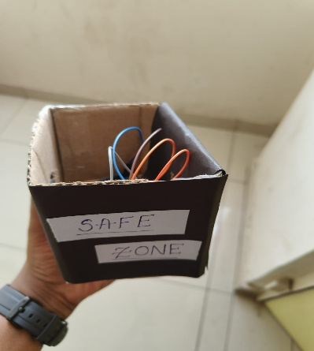  
 **COMPONENT CASING**

The system had a functioning locking system and did not allow the patient to pull out the device by himself. This was a key feature addressed by the system compared to options available in the market. The system had a clear indication of GPS positioning and connectivity on the OLED screen and was simple to operate and comprehend.

Battery testing led to the product achieving a level of operation of around 15-18 hours on a single charge, which was adequate to cover a full day usage. In offline mode (no network), data was retained by the system until it was available to send afterwards without a compromise on vital tracking data.

8 | P a g e

**CHAPTER 5**

**CONCLUSIONS AND FUTURE SCOPE**

**Conclusion:**

The **Safe Zone** project effectively addresses a critical need in the care of Alzheimer's patients by integrating wearable technology with real-time GPS tracking, geo-fencing, and SOS alert systems. By utilizing components like GPS, GSM, and Arduino Uno, the system ensures the safety and security of patients, offering peace of mind to caregivers.

Through its real-time tracking capabilities, caregivers can monitor the patient’s location at all times, and the geo-fencing feature provides an additional layer of security by alerting caregivers if the patient crosses set boundaries. The tamper-resistant locking mechanism ensures that the device remains secure and functional, minimizing the risk of accidental tampering.

Overall, **Safe Zone** offers a low-cost, practical solution to an increasingly important challenge. It enhances the ability to monitor and protect Alzheimer's patients while providing caregivers with the tools necessary for prompt intervention in case of emergencies. Moving forward, this technology has the potential to be expanded with more advanced features, such as enhanced AI-based monitoring or integration with other healthcare systems, making it an asset in the fight for patient safety and well-being.

9 | P a g e

**Future Scope:**

1. **MINIATURIZATION OF HARDWARE**

As technology advances, smaller and more power-efficient components can be used in place of current modules. For example, compact GPS and GSM modules, low-power microcontrollers, and flexible PCBs can be adopted. This miniaturization will allow the entire device to fit comfortably inside a standard wristwatch casing, making it more wearable and user-friendly for elderly patients.

* **Potential Impact:** Increased user comfort, improved aesthetics, and better long-term usability.
* **Example Technologies:** ESP32-based boards, NB-IoT chips, lithium-polymer flexible batteries.

1. **MOBILE APPLICATION DEVELOPMENT**

Machine learning algorithms can analyse historical movement patterns, walking speed, stop durations, and deviation from usual paths to detect abnormalities. If the system predicts disorientation, unconsciousness, or fall risk, it can immediately notify caregivers.

**Use Cases:**

* Predictive alerts based on unusual motion or inactivity.
* Monitoring deviation from routine paths.
* Early warning signs of cognitive decline or medical emergencies.

10 | P a g e

**OUR WEBSITE:**

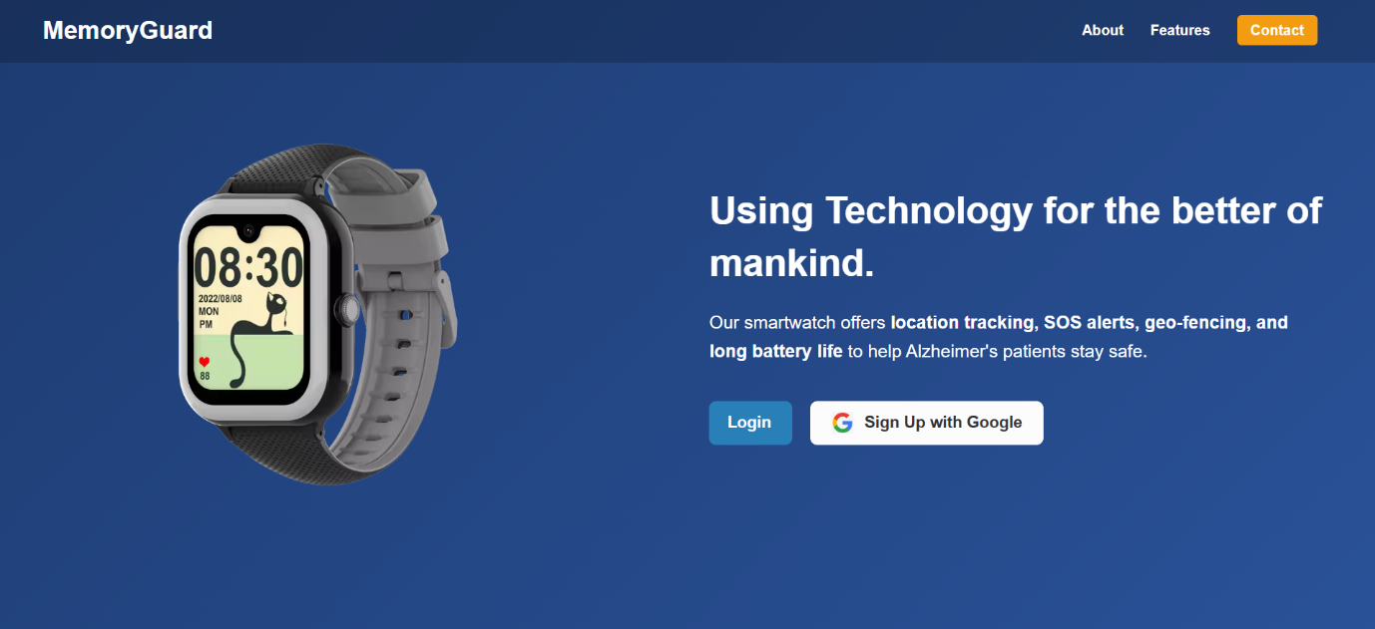**LANDING PAGE OF THE WEBSITE**

**SIGN IN INTERFACE**

11 | P a g e

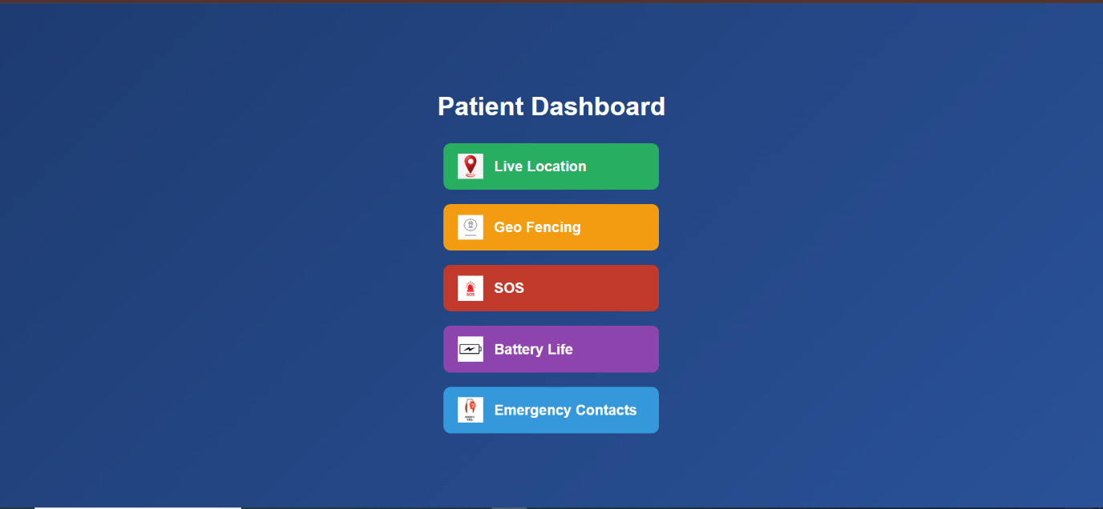**DASHBOARD OF THE WEBSITE**

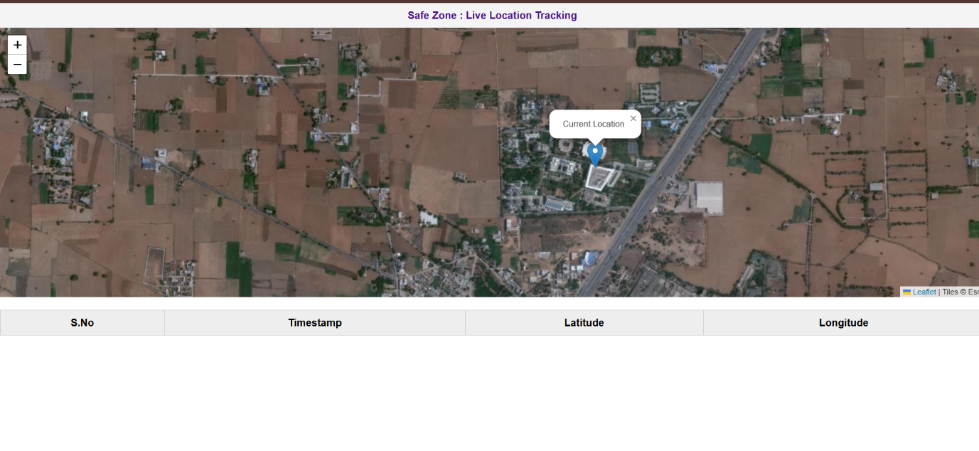 **LIVE LOCATION**

12 | P a g e

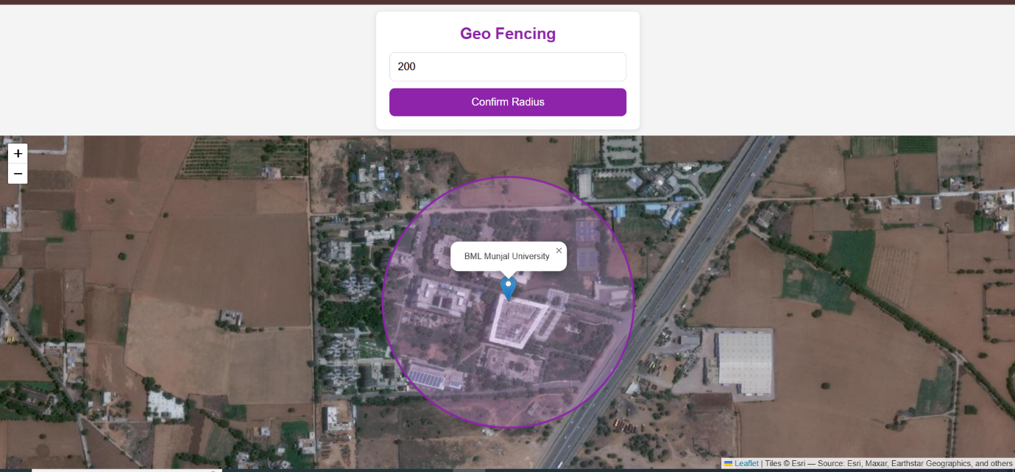**GEO FENCING**

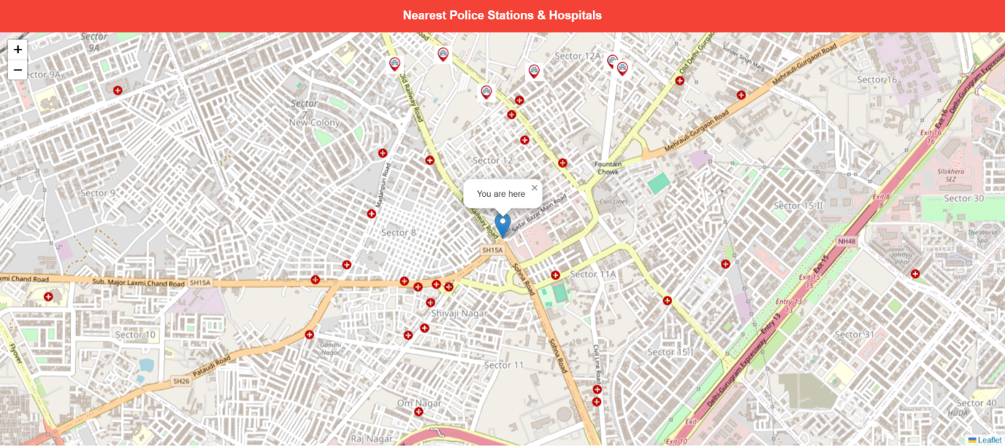**NEAREST POLICE HOSPITALS AND POLICE STATIONS**

13 | P a g e

**REFERENCES**

**[1] https://www.alz.org/help-support/caregiving/safety/technology-101**

**[2]**[**https://youtu.be/oT5pDvdMzhk?si=BFSr8iY5d7jiH22X**](https://youtu.be/oT5pDvdMzhk?si=BFSr8iY5d7jiH22X)

**[3]**[**https://youtu.be/R-Rcbj_qR4g?si=PJlI3FaIL_BuG4fh**](https://youtu.be/R-Rcbj_qR4g?si=PJlI3FaIL_BuG4fh)

**[4]**[**https://youtu.be/oT5pDvdMzhk?si=BFSr8iY5d7jiH22X**](https://youtu.be/oT5pDvdMzhk?si=BFSr8iY5d7jiH22X)

**[5] https:/ieeexplore.ieee.org/abstract/document/8653658**

**[6] https:/ieeexplore.ieee.org/abstract/document/8653658**

**[7] https://pmc.ncbi.nlm.nih.gov/articles/PMC11290024/**

**Plagiarism Report** *(use the credentials of Turnitin)*